**STAY FIT!**

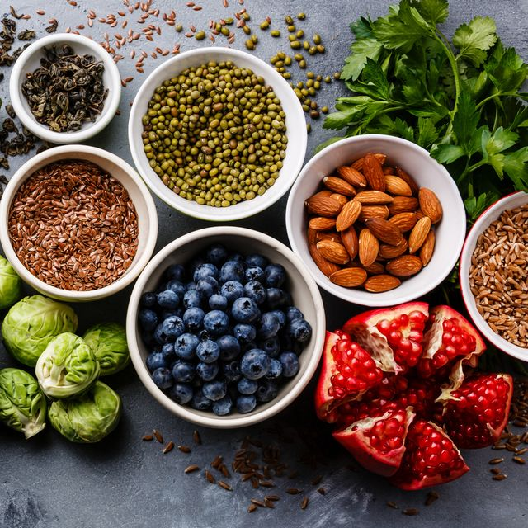

* **MORE FRUITS**
* **MORE VEGETABLES**
* **EAT HEALTHY**

**SHAPE YOUR**

**BODY!**

* **SMILE MORE**
* **LOOK BEAUTIFUL**
* **WORK OUT**
* **WAKE UP**