Traveling itinerary of a 5-day trip to China
- I am going to vist the capital city of China, Beijing.
I have chosen this country becouse i really love their culture and i consider it for the most interesting in whole world, I really like the chinese buildings and monuments, which ones i would like to visit.

- I have decided that the best way how i can travel to china is by airplane, and the reason is becouse its the fastest and also the most comfortable way how to get there. The tickets for airplane to China are expensive so i found the two ways how you can travel to China cheaper you must to buy tickest in advance or ´´last minute´´, I prefere to buy tickest last minute becouse when you buy tickets in advance you can get sick or some sickness started in coutrny and you can´t travel there and you will lose your mony for tickets.

- I would like to visit a lost of monumnets and explore the culture form buildings through food until shopping.

- First Day- I decided to visit The Great Wall becouse i think everyone know this monument, because its second most visited place in the world. I am going to travel there with the fastest train in world, this trains you can find only in China, its the fastest and cheap .

- Second Day- All this day i want to spend about culture of Chinese food, I consider the chinese meals for delicious, becouse it includes seafood, noodles, some really crazy candies ect. I found some good restaurands and some ´´streetfood boxes´´ which ones i would like to visit. I think there is no one whose don´t like chinese food.

- Third Day- This day i am going to visit the biggest shopping center in Asia, its called ´´ The Malls at Oriental Plaza´´ .This shopping center is famous for clothing brands which ones we can found there, We can found there brands like (Gucii, LV, Supreme ect.) And aslo there is the biggest aquarium with sharks and some see monsters. I wold like to buy some clothes there becouse i love fashion.

- Fourth Day- I am going to visit The Forbidden City its museum and also monument, this buing was found only by misstake, it was hide behind the bushes and somenone found it, inside this buinding was a lost of findings which ones are exposed now in the museum The Forbidden City. This monument uncover a lots of unclear things in Chinese history.

- Fifth Day- This is my last day here in Beijing so i want to visit Beijing Botanical Garden, there we can see some crazy flowers and trees , there is the typical park full of Pink trees like you can know form movies shoted in China. Then i booked the tickest for concert of my favourite band ´´Twetny one pilots´´ which are going to have concert in Beijing Sport Hall in which should be Olympic Games 2020

- I am going to stay in Airbnb for 3 days becouse, I don´t want to send so much money for housing, becaouse all time i would be exploring monumnets and I will come here only to sleep, and next 2 days I will stay in small box or capsule house which ones are very famous there, becouse they are practical and cheap.

- I have planed my trip during summer holydays, after i earn some money in my part-time job. I am not quite sure in which month i am going in China it depends of tips in my part time job becouse i am working in cafe and i am not earning so much money. I hope i will go in August so i will take only backpack and some basic clothes like one shoes, longsleeve T-shirts, shortsleeve T-shirt and jeans, of course some hygienic stuff, I am taking not so much stuff becouse i want to buy the clothes there, and thats the reason why i planed shopping for one whole day, and also i don´t want to play for extra luggage.

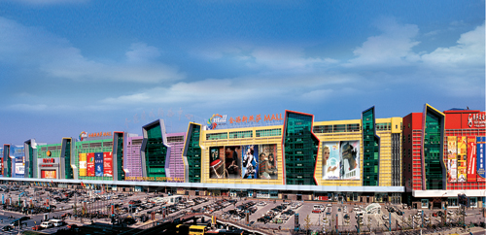
Here i add some picture of housing, monuments..
Shopping Center
Vypracoval: A. Mitter, 3.A

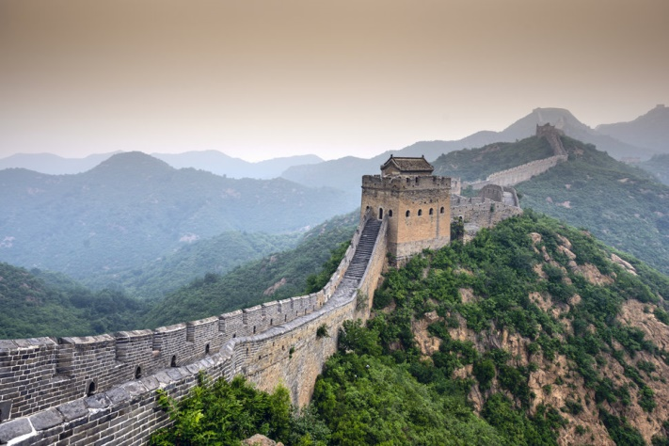

The Great Wall

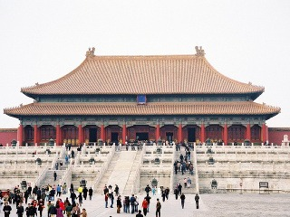
The Forbidden City

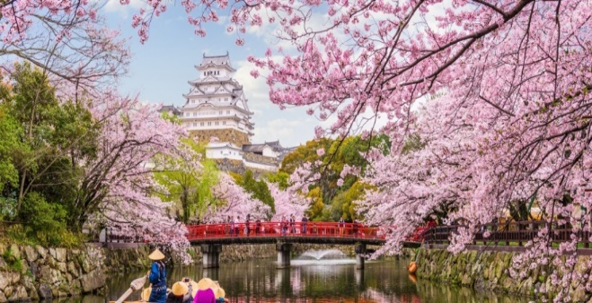
Bejing Botanical Garden

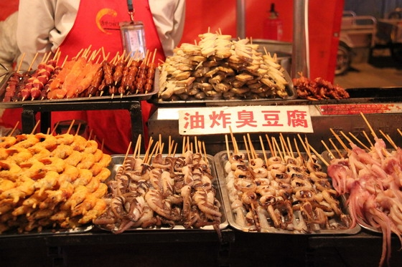
Some food i would like to taste

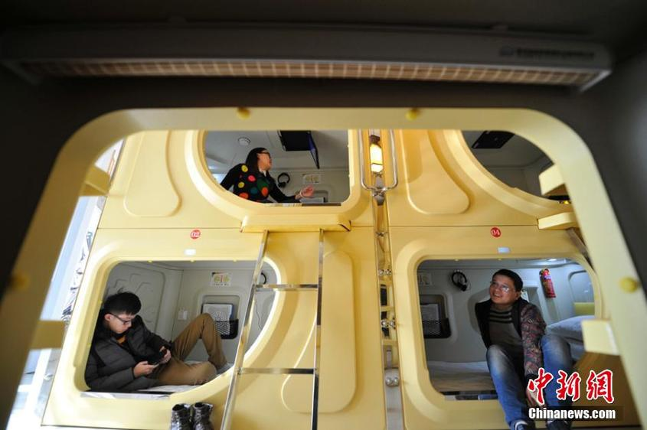

Housing

