Traveling itinerary of a 5-day trip to LAOS

1. Why I´ve chosen this place?
I have chosen this place ´cause I love travelling to exotic destinations. Laos has always been my traveling dream. There are many beautiful monuments and interesting culture. I ´ve never been in Asia, so this is gonna be my first „stop“ in Asia. Laos has a dramatic mountain nature. There are hidden royal residences. Many caves, waterfalls and the temples of buddhism etc.

2. How are you going to get there?
We ´ll go to the airport in Vienna by car. If we arrive to the airport, we hand over our luggages and go over a control called check-in and then get our seat assignment. Our departure is at 8.00 am local time. We are flying to Bangkok where we transfer to flight to Vientiane (capital city of Laos) at 18.00 pm. After arrival in Vientiane at 23.00 pm local time, we are taking a taxi to our resort in Wattay. Our dear delegate gave us contact to the taxi service here. Travel to our hotel will take 2 hours.

3. Activities you are going to do there, landmarks you are going to see. Here write a 5-day itinerary

1st day
Arrival to five star Crown Plaza Hotel.

- Crowne Plaza hotel is the most famous resort in Wattay
- It has good reviews from all of the people who stayed here
- First day Pay deposit – 860€
- The price includes: accomodation, food, wellness, travel insurance
- The price doesn´t include: monument tickets, educational trips, catering outside the resort
- Crown Plaza Equipment: free WIFI zone, food (including mini bar), pool, AC, business centre
In the evening we are going for a walk trough the city, watch at the performance of the locals.
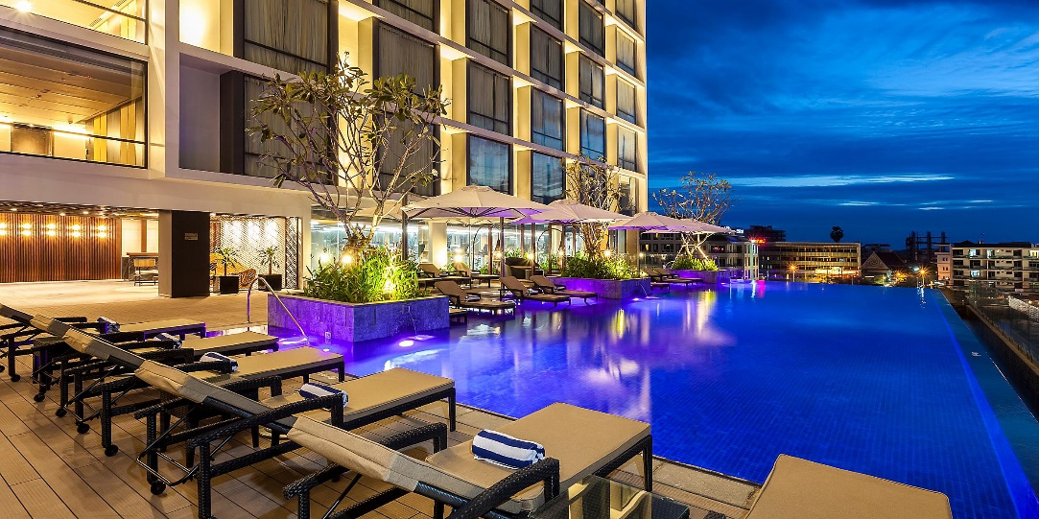
2nd day
- Alarm at 6.30 am
- 7.00 - breakfast
- 8.00 tour of the royal city Luang prabang – we are going to see the province of Laos
- Luang Prabang is situated on the riverside of Mekong
- 11.00 sightseeing tour to formal Royal palace
- There are a lot of interesting historical items
- Every item tells a story - you will learn quite a lot about Laos history and about Laos’ royal
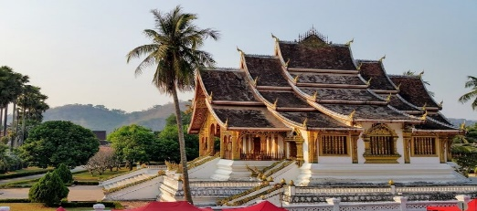
3rd day
- Alarm at 7.00 am
- 7.30 breakfast
- 9:00 cruise on the Mekong river to Luang Prabang
- 10:00 Visiting cave called Pak ou
- The caves are noted for their miniature Buddha sculptures
- Hundreds of small wooden Buddhist figures are laid out over the wall shelves
- They take many different positions, including meditation, teaching, peace and rain
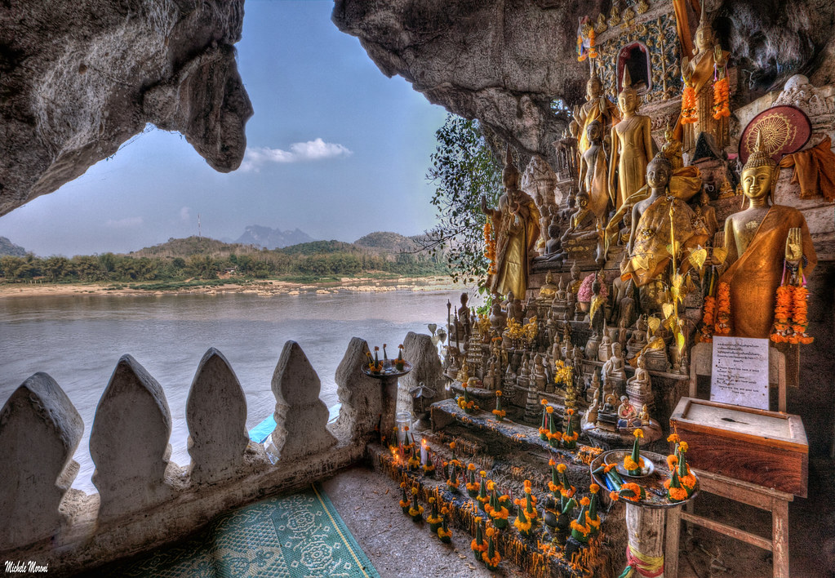

4th day
- Alarm at 4.30am and watch the most beautiful sunrise in this region
- 7.00 breakfast
- 8.00 scuba diving the Mekong river
- 12:00 moving to elephant camp nearby Mekong river
- 13:00 trip to island landscape Si pan don
- 15:00 visiting beautiful waterfall called Liphi
- They are located on the remains of french railway
- The endangered freshwater Idaho dolphins can be seen there

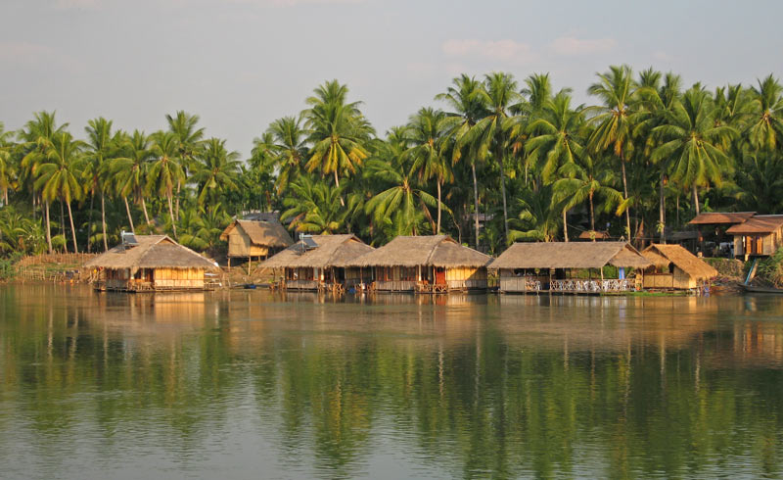

5th day
- Alarm at 6.00 am
- 7.00 breakfast
- 8:00 transporting to Angkor Wat by shuttle
- Tickets were bought at the hotel – 35€ for one person
- Visiting Hindu temple complex in Cambodia
- The largest religious monument in the world
- Magical stone silhouettes faces
- 350m long beautiful elephant terrace
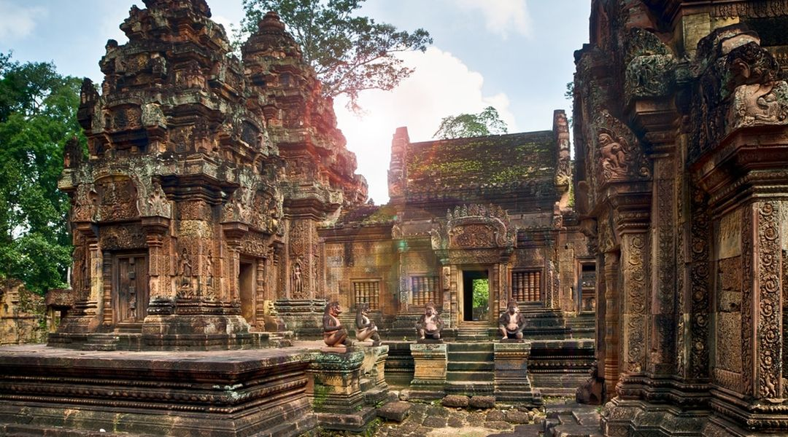
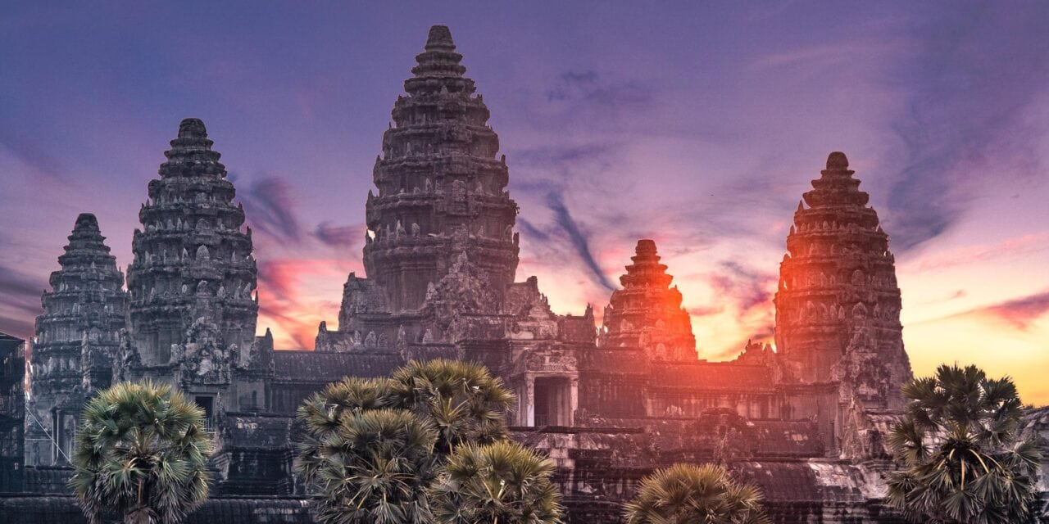

6th day
- Alarm at 9.00 am
- 9.30 breakfast
- 10.00 going sightseeing in Wattay
- 12:00 lunch at hotel
- Pay 860€ for the second half of stay
- 14:00 departure by taxi to the airport in Wattay
- 17:30 plane departure to Bangkok. Then transfer to Vienna at 19.00 pm local time
- Arrival to Viena at 3.30 am, then we go home by car

4. Where are you going to stay? type of accomodation
I have it already written in question number 3. Sorry, I haven´t followed the order of questions. I thought it was appropriate to write it at the beginning of this project.

5. What to take with you according the type of weather , season
At first we have to pack our passports. This is the most important thing. Without them we can´t go anywhere. And given that we are going on vacation in August, we have to take swimsuit, sun creams, slippers, something to protect our head from burning. In case we get burned, we need to pack also first aid spray with contents panthenol. If there was a storm, and it gets cold, we take some sweatshirts and long jeans. For the occurents of insects we need to an insect repellent. Hope I won ´t forget anything important.

Vypracovala: I. Trebatická, 3.A

